# DAD 220 Module Seven Major Project – Devin Perry

Begin by writing SQL commands to**capture usable data** (which you’ve preloaded into Codio)for your analysi

Specifically, the product manager wants you to analyze the following:

* + A picture containing timeline

    Description automatically generated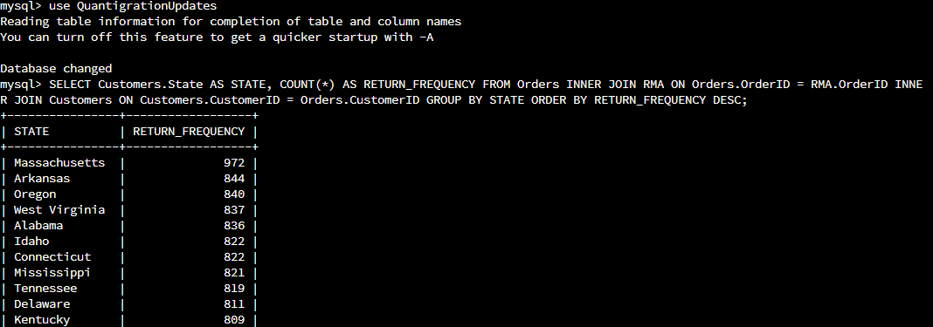**Analyze** the **number of returns** **by state** and describe your findings in your report.

**The top ten states with the most returns are shown above in the screenshot. The other 40 states and their data is shown in the second screenshot. Something to note is that there is the largest customer base in Massachusetts, so it makes sense that the state has the most returns. For the most part, that pattern follows true where there is a ratio between a higher customer count and higher number of returns.**

* + **Analyze**the **percentage of returns by product type** and describe your findings in your report.

**The code I ran allowed for the 9 different products to be analyzed to see which one had the most returns. The BAS-48-1 C had the highest number of returns. In contrast, the BAS-24-1 C had the lowest number of returns.**

In your report, clearly **summarize your analysis of the data for stakeholders**. Include screenshots of the results of each query. When summarizing results, you may want to consider the following questions:

* 1. How does the data provide the product manager with usable information?
  2. What are the potential flaws in the data that has been presented?
  3. Are there any limitations on your conclusions, or any other ways of looking at it that you haven’t considered? Clearly communicate your findings to stakeholders.

**The data shown above allows for valuable insight into where people are returning the products the most, and which products are being returned the most. This allows for valuable insight into different angles that can be taken to reduce returns and where they can be. The states with the highest returns should be looked into why the products are being returned. Perhaps the reason is not because of the quality of the product, but maybe it is too cold to use them or something like that. Some potential flaws in the data could include the total number of products returned as sometimes data can be put in wrong. Something notable that is not necessarily an error but is to look at how many customers are in the states that have higher returns. It makes sense that states with higher customers also have higher returns because there are more people to be unsatisfied. Similarly, to what I just said, there are other factors that should be looked at when checking this data. Perhaps the highest returned product is also the most sold, or maybe it has something wrong with it. These factors should also be looked at before looking at the raw data presented and coming to any conlcusions about it.**